Shorts to Features 2019-20
APPLICATION FORM

In partnership with

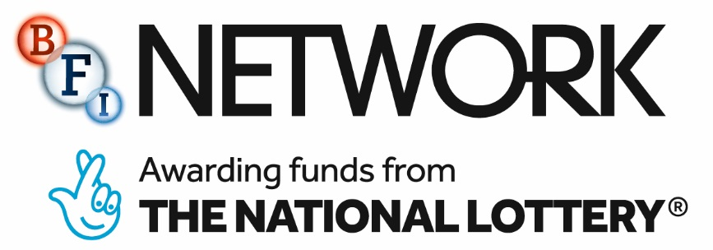

Please type or write in capitals:

Applicant producer full name: |  | Home Tel.:
Email: |  | Mobile:
Full postal address
Including postcode

Eligibility:

I the undersigned confirm that I:

- The creative team attached has at least three previous short film credits on either independently financed or funded projects.
- The creative teams are legal residents of Northern Ireland.
- The feature project submitted has been in receipt of development funding from Northern Ireland Screen.

Additionally, I understand that:
The development work will be based in Northern Ireland and I will need to make myself available for all development meetings, at my own expense, for the duration of the scheme.

Signed: Dated:

Enclosures:

Along with this completed application form please enclose the following:

- Links to view previous films from the creative team.

- Up to two outlines of short film ideas for a proof of concept short film which is tonally aligned to the submitted feature project (up to 15 mins in length - no more than one A4 page per outline please).

- Current CV with full contact details for all the creative team attached.

• Completed monitoring forms for the creative team.

PLEASE NOTE:
Failure to provide the requested documentation at the time of application will result in elimination from the selection process.

Send all pages of the completed application form, along with all required application materials to:

Shorts to Features 2019-20
Northern Ireland Screen
3rd Floor, Alfred House
21 Alfred Street
Belfast
BT2 8ED

Deadline for receipt of applications: 5pm Friday 5th July 2019

PLEASE NOTE: under no circumstances will applications be accepted after this deadline. Applications cannot be submitted by email or fax.

DECLARATION
Northern Ireland Screen is required to identify all relevant financial or personal interests that may exist between board members or employees of Northern Ireland Screen and applicants. This is to ensure that measures can be introduced to prevent a conflict of interest arising between those persons assessing the application for Northern Ireland Screen and such applicant. For these purposes please complete the statement below:

“I (or the person on whose behalf I am applying) do not have any financial and / or close personal relationship with any Board member or employee of Northern Ireland Screen. The nature of such relationship is as follows” (e.g. spouse, relative, financial interest - please specify details)

*Delete as applicable

_____________________________________

I have read and understood the Northern Ireland Screen application guidelines. The information I have given on this application is true and correct. Any material I have sent to support my application is also true and correct. I will tell you immediately if this information or the supporting material needs to be updated. I am happy for you to provide copies of this form and any supporting material to any person or organisation you wish to consult about my application. I am authorised to make this application and accept a conditional offer. I also have the authority to repay Northern Ireland Screen in the event of the conditions not being met.

Signed: Date:

Data Protection
Part or all of the information you give us will be held on computer and used for statistical purposes. It will also be used for the administration of applications and awards. We may provide copies of the information in confidence to individuals or organisations who are helping us assess applications or monitor funding and may also be shared in connection with these purposes with other companies in the Northern Ireland Screen group of companies.

