Shorts to Features 2019-20
GUIDELINES

In partnership with

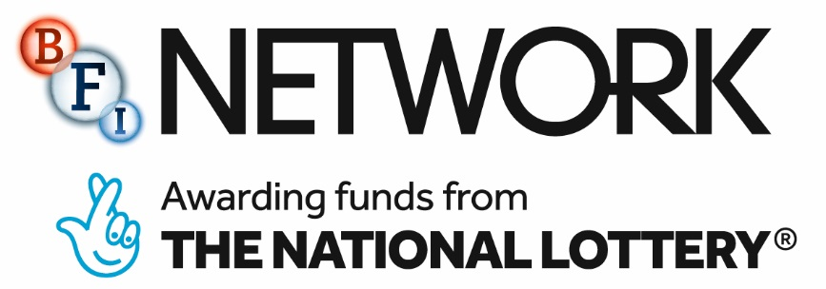

SHORTS TO FEATURES 2019/20
Submission process The Scheme is open on a rolling basis and applicants can submit applications up until Thursday 31 October 2019 at 17:00.

Duration of Scheme An initial development process takes place until March 2020 with a script editor. The production process for 1 selected project after initial development period. There is the possibility of transport bursaries for participation on the development scheme if required.

Production Budget £20,000

Application criteria Applicants must apply with the current draft of their feature film project and one-page outline for a proof of concept short which is tonally aligned to the feature film project. The feature project submitted must have previously received development funding from Northern Ireland Screen and be at financiers draft stage.

Who can apply? Emerging talent (writer, writer/director and producer teams) with at least three previous short film credits in chosen grade. Both funded and independently made projects will be considered at application stage.

Submission materials Please fill out and return the application form online via the Northern Ireland Screen portal.
Northern Ireland Screen and the BFI are committed to ensuring that we consult with active practitioners within the deaf and disabled filmmaking community about current and future projects where there is a portrayal of deafness and disability and also in respect of industry access. We want to see films that are authentically and mindfully cast with deaf and disabled actors and also see more non-specific casting, creating roles and visibility for deaf and disabled actors which do not reference disability as part of the theme or narrative.
In support of this and to avoid reinforcing negative stereotypes, we will no longer support work featuring facially scarred villains. Supporting equal pay for deaf and disabled actors and filmmakers means that Northern Ireland Screen will now consider applications that include project costs related to access requirements for deaf and disabled practitioners and will have the ability to provide funding for such elements in addition to a scheme’s normal funding cap.

